Dear ________,

Thank you so much for your generous donation to our _____ DreamCatchers chapter. You are helping us making more Dreams come true for hospice patients like Bernie- who wanted to sail one last time before he passed away. We took him out on a sailboat one last time and the smile never left his face. (fill in with any Dream you’ve granted or experience you’ve had as a club)
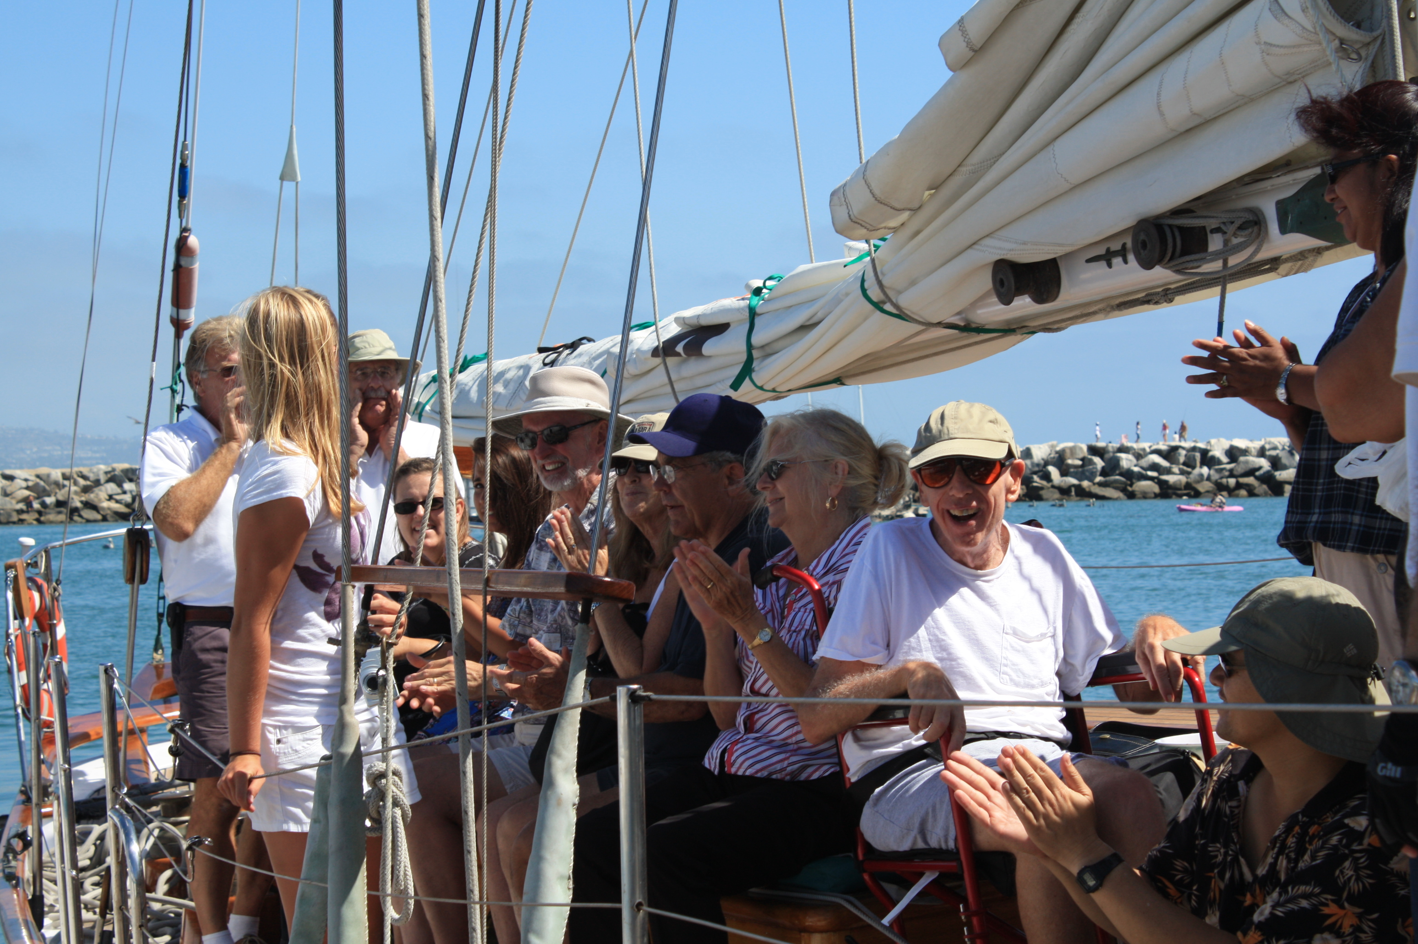

DreamCatchers Foundation is a 501(c)(3) organization, so all contributions are tax deductible.

DreamCatchers tax ID number is 05-0634716 for your records.

Thank you so very much for your help with this generous contribution. Please watch our progress at www.dreamcatchers1.org , and on social media: INSERT SOCIAL MEDIA PAGES HERE

Sincerely,

________ and the ______ DreamCatchers chapter

